Carpool Cheats



In this project you will make a smart traffic camera that recognizes if a car is allowed to be in the carpool lane.

You will teach the computer to recognise whether there are passengers in the car by giving it examples of pictures of cars with and without passengers.

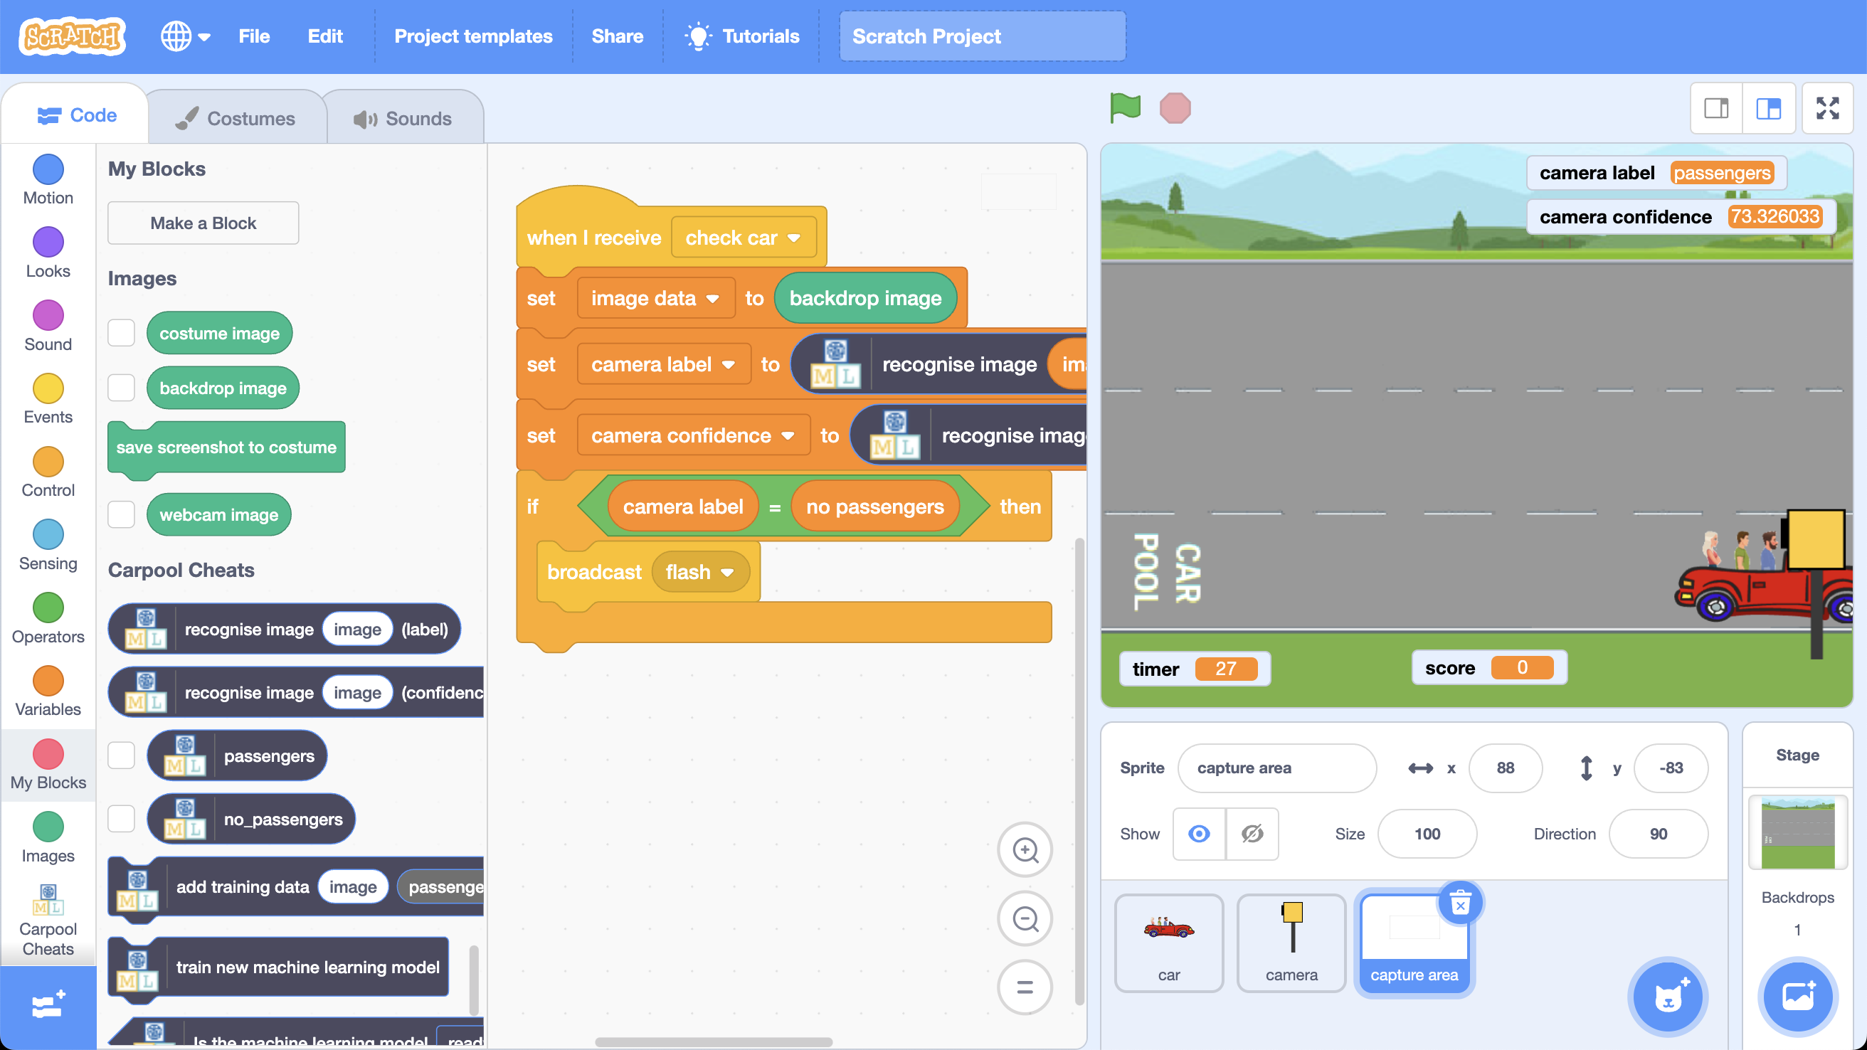

This project worksheet is licensed under a Creative Commons Attribution Non-Commercial Share-Alike License

http://creativecommons.org/licenses/by-nc-sa/4.0/

1. Go to <https://scratch.machinelearningforkids.co.uk>
2. Click on the **Project templates** menu
3. Click on the “**Carpool Cheats (test)**” project
4. Click on the full-screen button  
   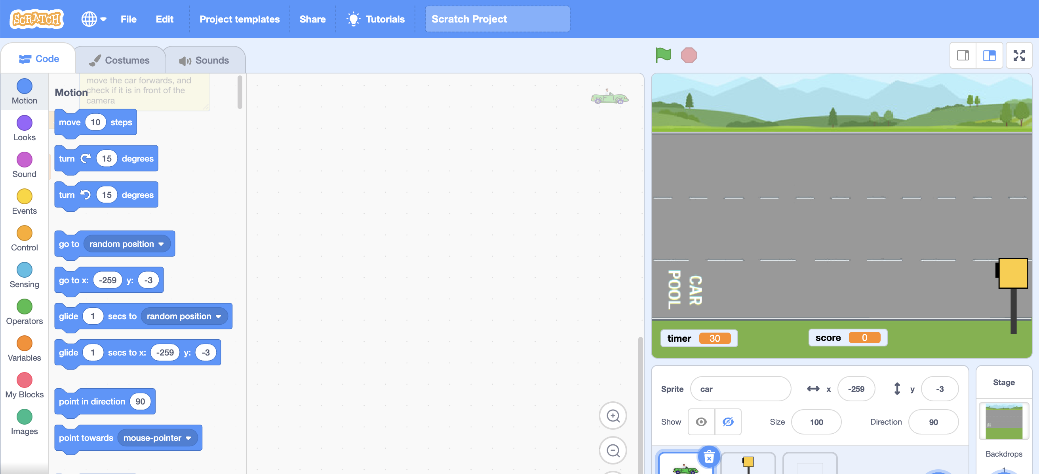

You will have 30 seconds to get as many cars along the road as you can.

Cars drive at different speeds depending on which lane they are in.

|  |  |  |
| --- | --- | --- |
| **medium** speed |  |  |
| **slow** speed |  |  |
| **fast** speed |  | Only cars **with passengers**  are allowed to use this lane |

Cars always start in the middle, slow lane.

You can change lanes using the **up** and **down** arrow keys.

Use the **up** arrow for cars with only a driver.

Use the **down** arrowfor cars with passengers.

The yellow traffic camera is there to catch the **Carpool Cheats** – cars with only a driver that try to use the bottom carpool lane!

If it catches you, you will lose points.

1. When you are ready to try the game, click on the **Green flag**

You probably noticed that the traffic camera isn’t very smart.

It can’t tell the difference between a car with only a driver and a car with passengers.

It gives a fine to every car that goes past!

In this project, you will train a machine learning model to recognise if a car has passengers, and use this to make a smarter traffic camera.

1. Go to <https://machinelearningforkids.co.uk/>
2. Click on “**Get started**”
3. Click on “**Try it now**”
4. Click the **“+ Add a new project**” button.
5. Name your project “Carpool Cheats” and set it to learn how to recognise “**images**”.   
   Click the “**Create**” button  
   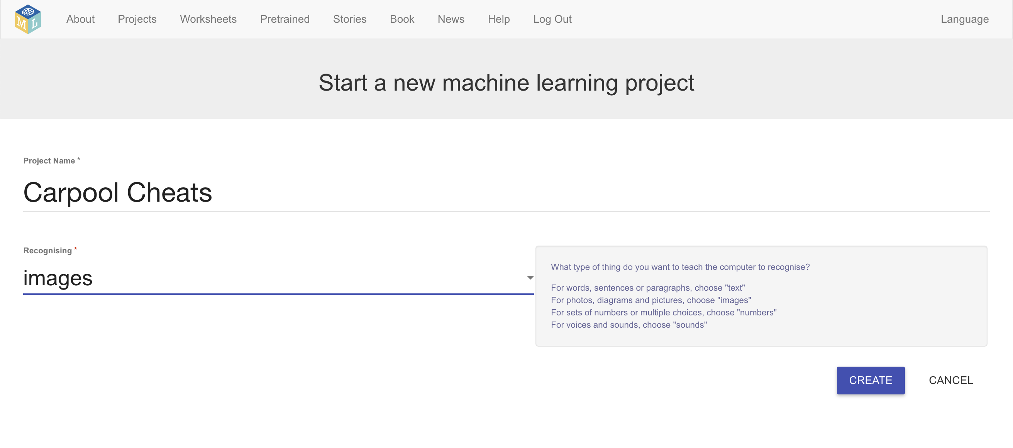
6. You should now see “**Carpool Cheats**” in the list of your projects. Click on it.
7. Click the **Train** button  
   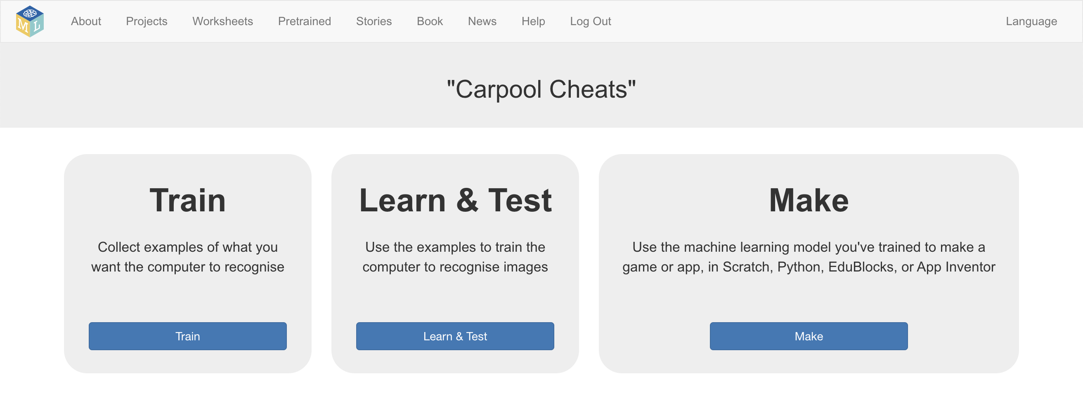
8. Click on **“+ Add new label**”   
   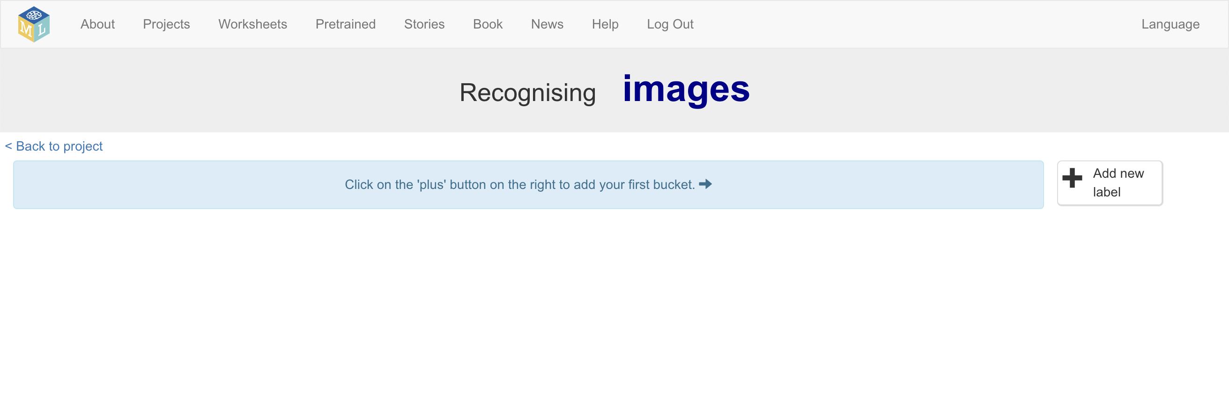
9. Call your first label “**passengers**”  
   *This will be where you store examples of pictures of cars with passengers*  
   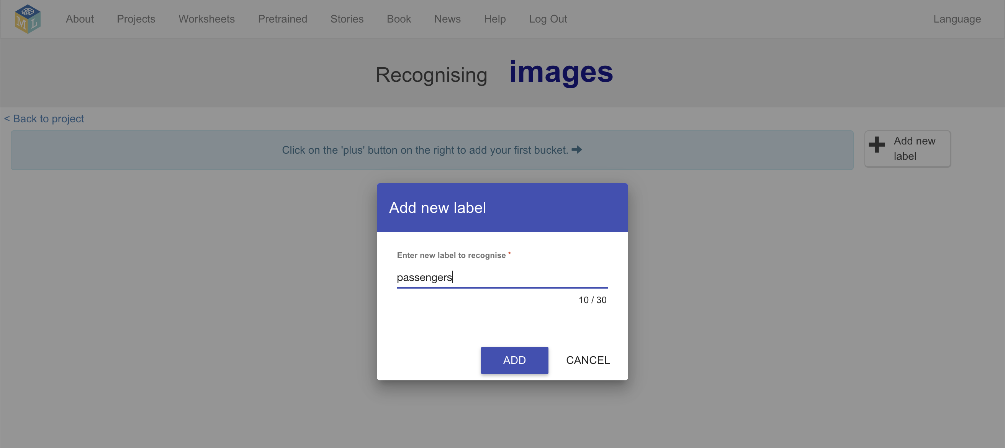
10. Do that again, and create a second bucket called “**no passengers**”.  
    *This is where you will store examples of pictures of cars with only a driver*  
    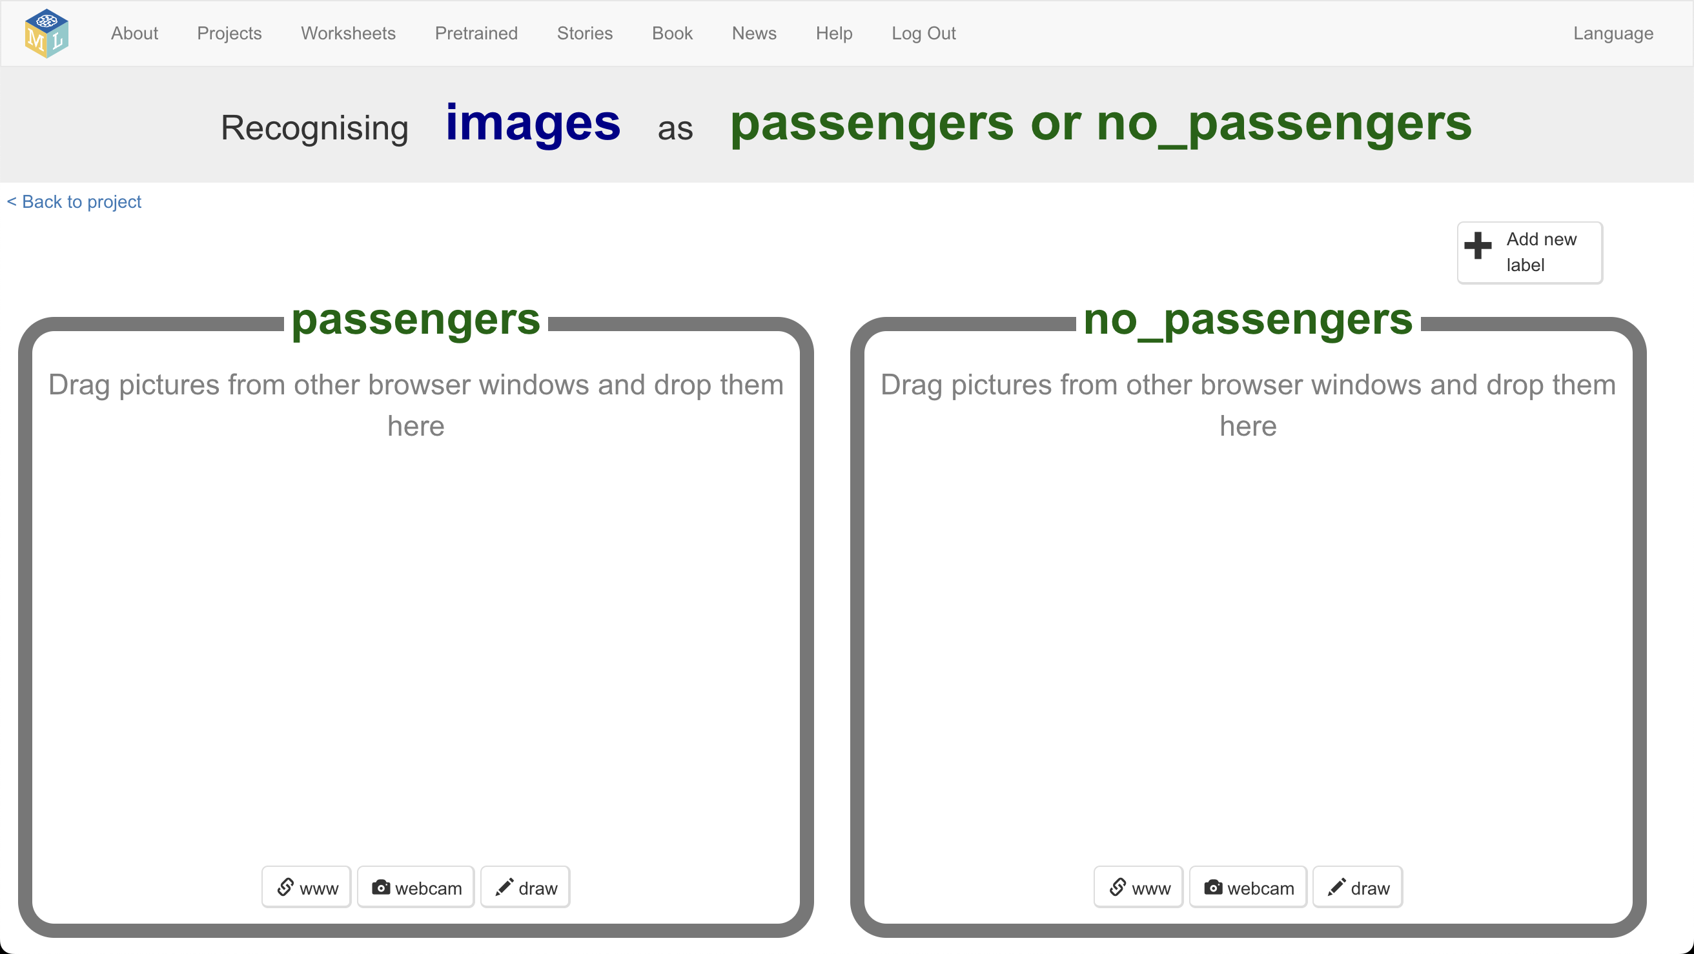
11. Click on the **“< Back to project**” link in the top-left
12. Click on the “**Make**” button.
13. Click on the “**Scratch 3**” button
14. Click on the “**straight into Scratch**” button  
    *The page is warning you that you don’t have a machine learning model yet. That is okay, as you will be using Scratch to collect training pictures and use them to train your machine learning model.*  
    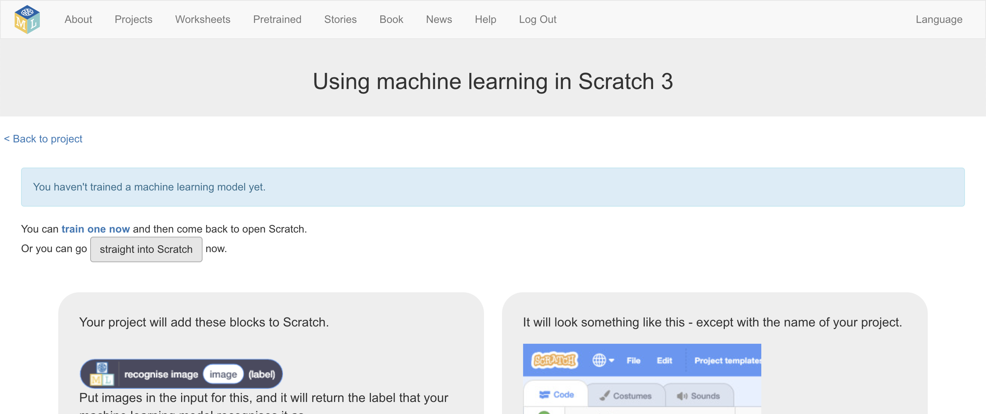
15. Click on the **Project templates** menu
16. Click on the “**Carpool Cheats (train)**” project  
    *This is a* ***different*** *project to the one you used before!  
      
    You will use this Scratch project to collect training examples: examples of pictures of cars with and without passengers.   
      
    You can use these examples to train the computer to recognise what a car without passengers looks like.*
17. Click on the **Stage** and find the **prepare training labels** code  
    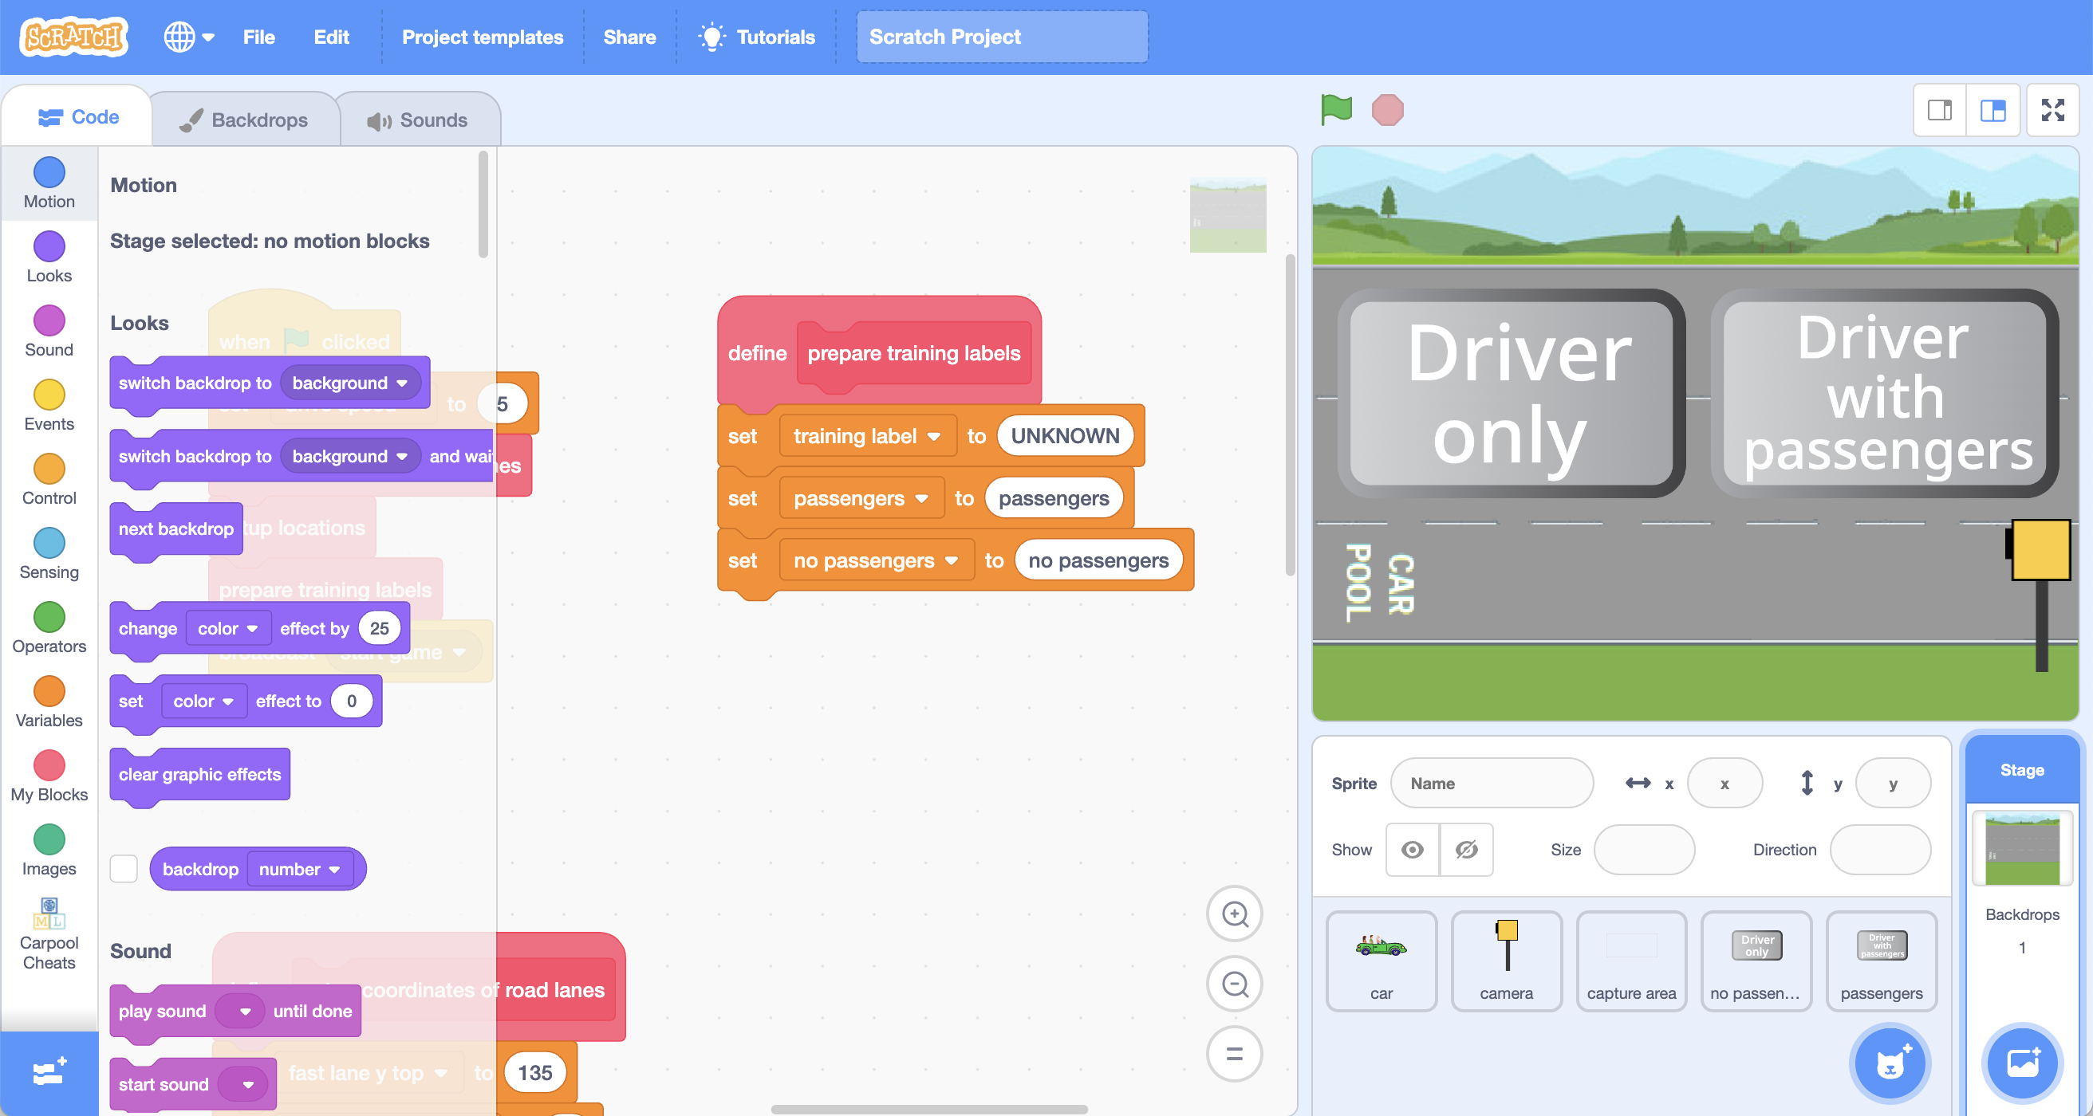
18. **Add** blocks from your machine learning project to this code  
    *You need to make it look like this:*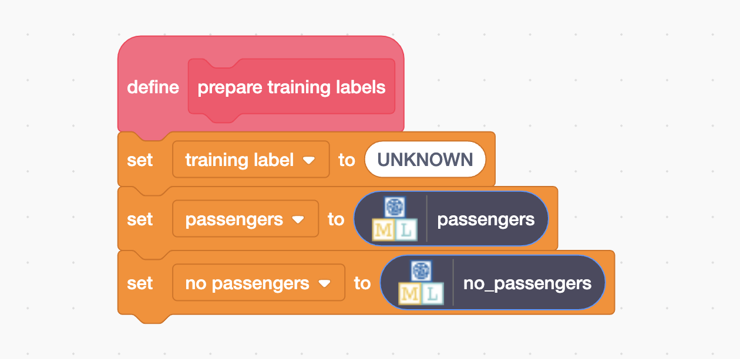
19. Click on the **capture area** sprite and find the “**check car**” code  
    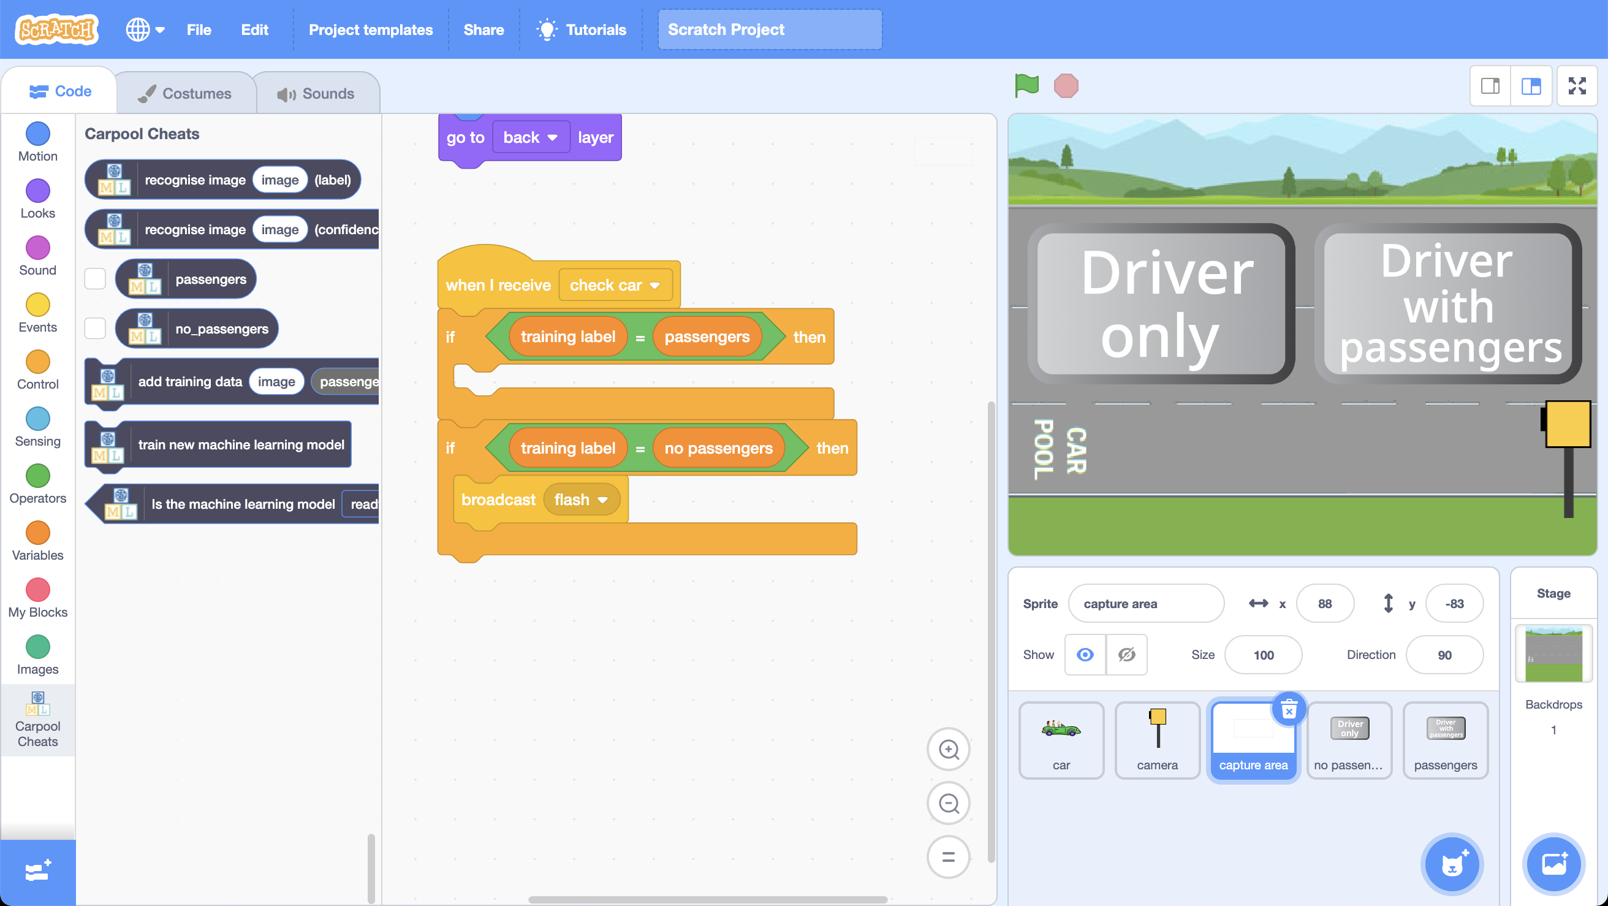
20. **Add** blocks from your machine learning project to this code  
    *You need to make it look like this:*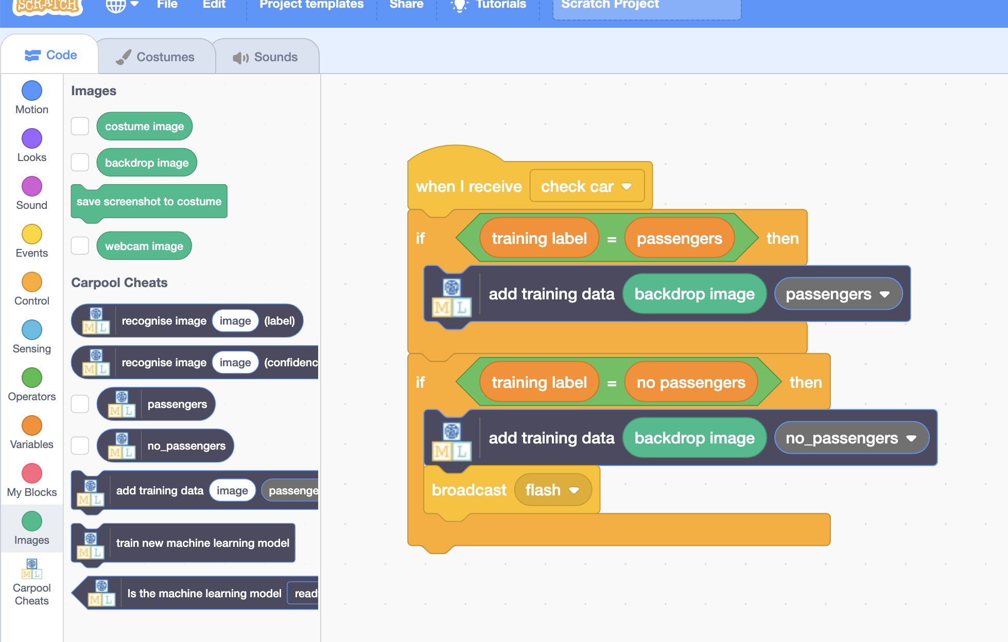  
      
    *This will add a picture of whatever is in front of the traffic camera to one of the training buckets you created for your project.*
21. Click on the **full-screen** button
22. Click on the **Green flag***It’s time to train!  
      
    You will see a series of randomly selected cars – some with passengers, and some with only a driver.  
      
    Click on the “Driver only” or “Driver with passengers” button to add the picture of the car to your training bucket.  
      
    Collect pictures of about* ***ten*** *cars  
      
    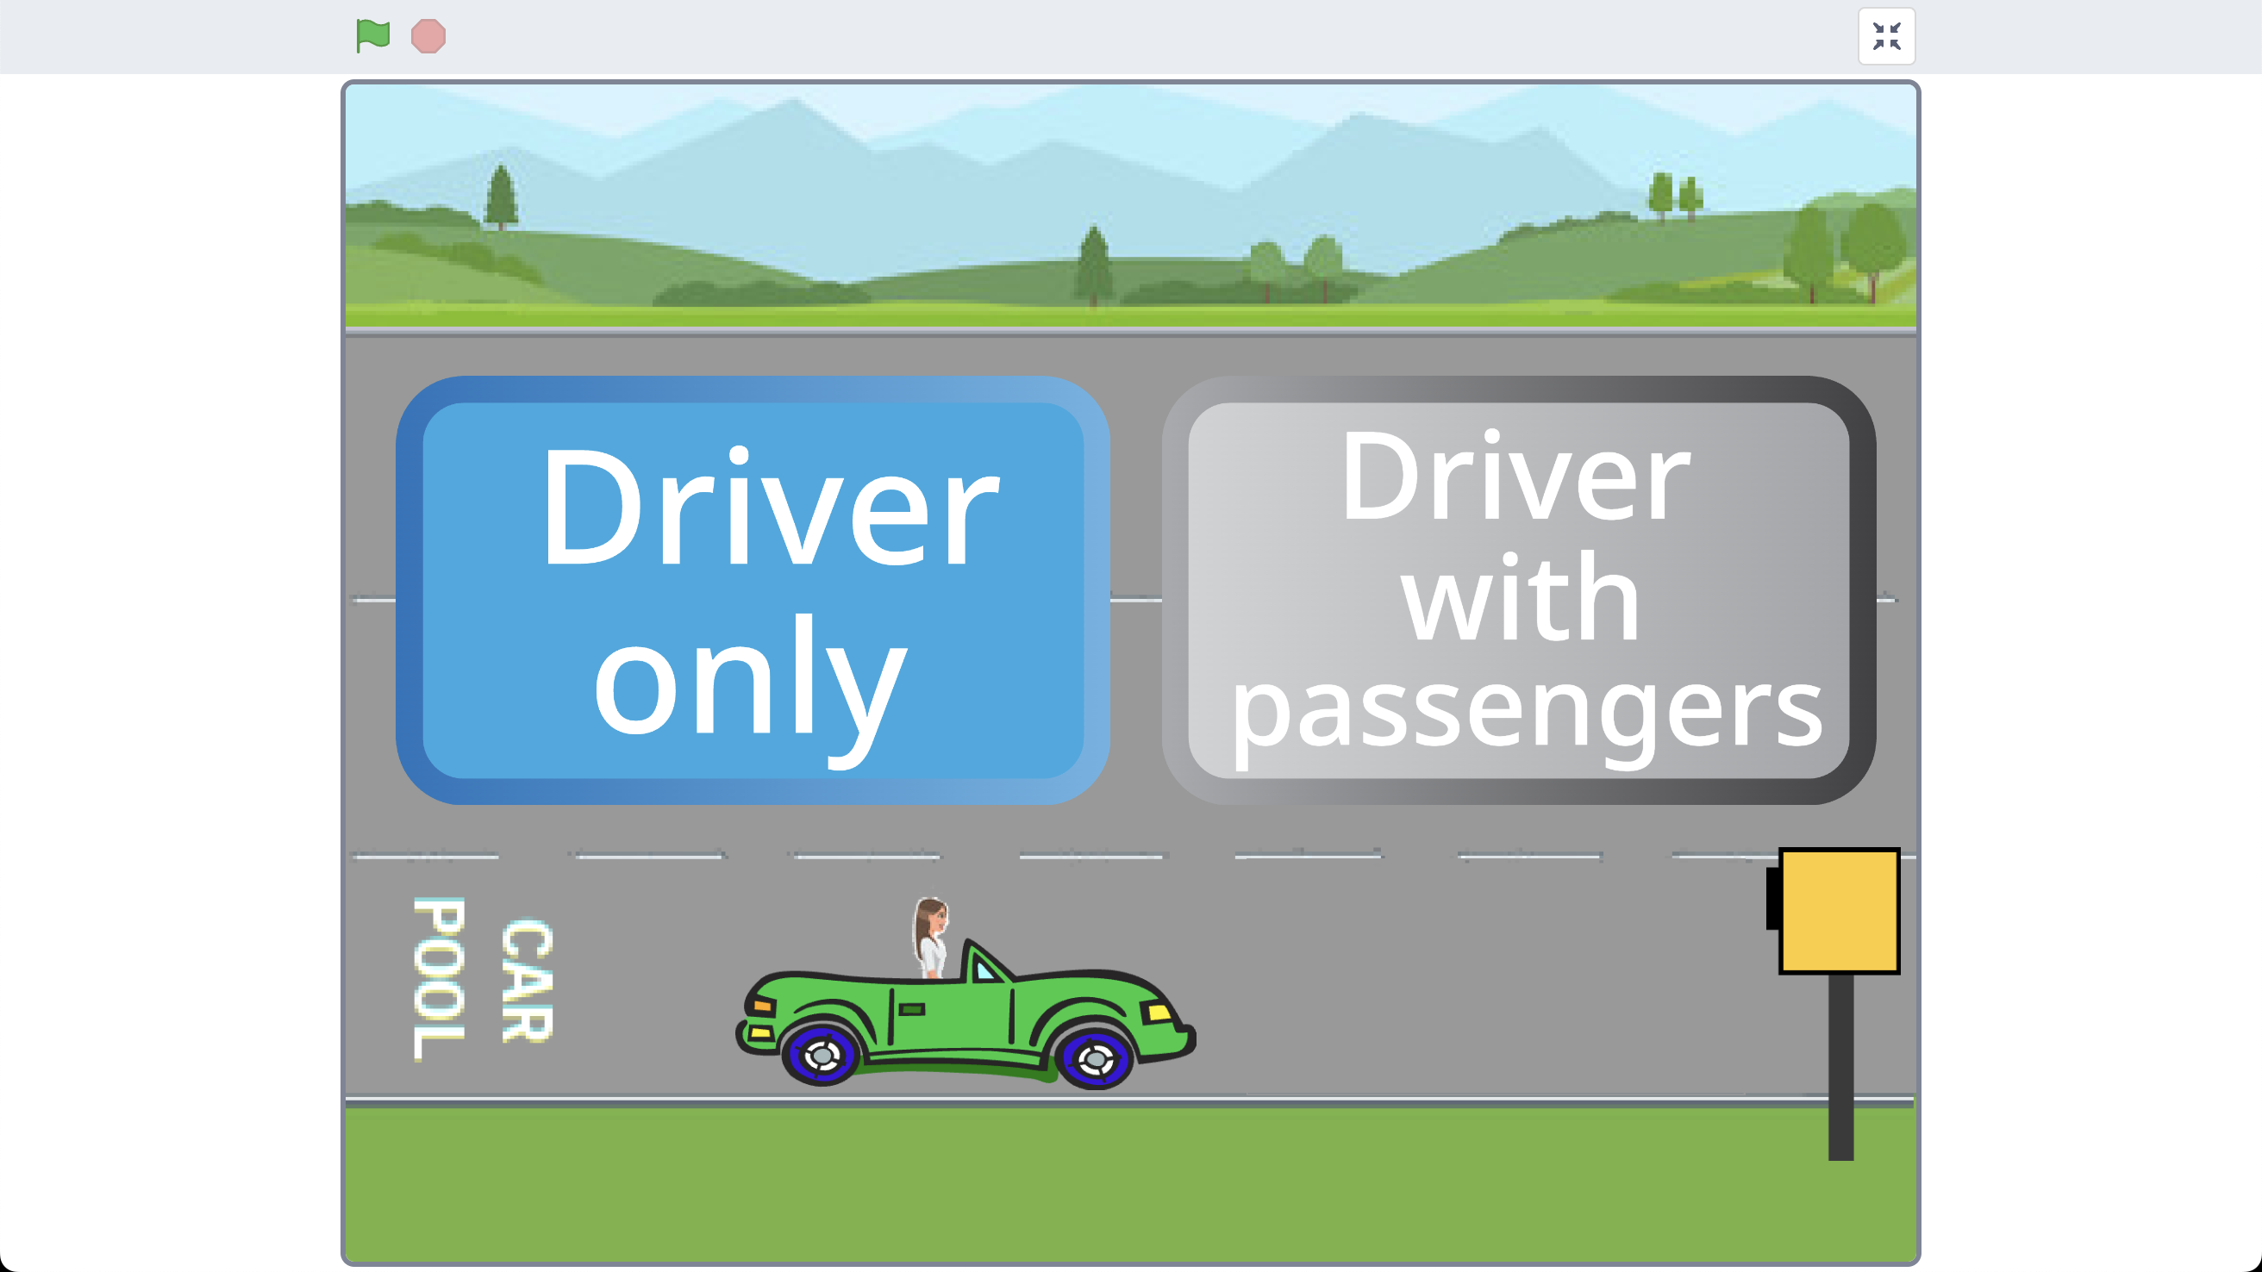*
23. In the training window, click on the “**< Back to project**” link  
    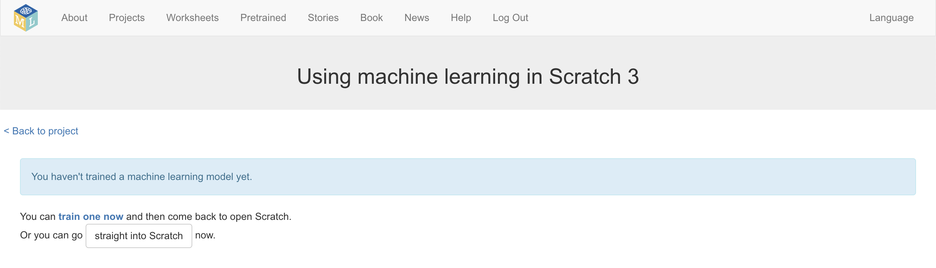
24. Click the **Train** button
25. Look at the training pictures that you’ve collected  
    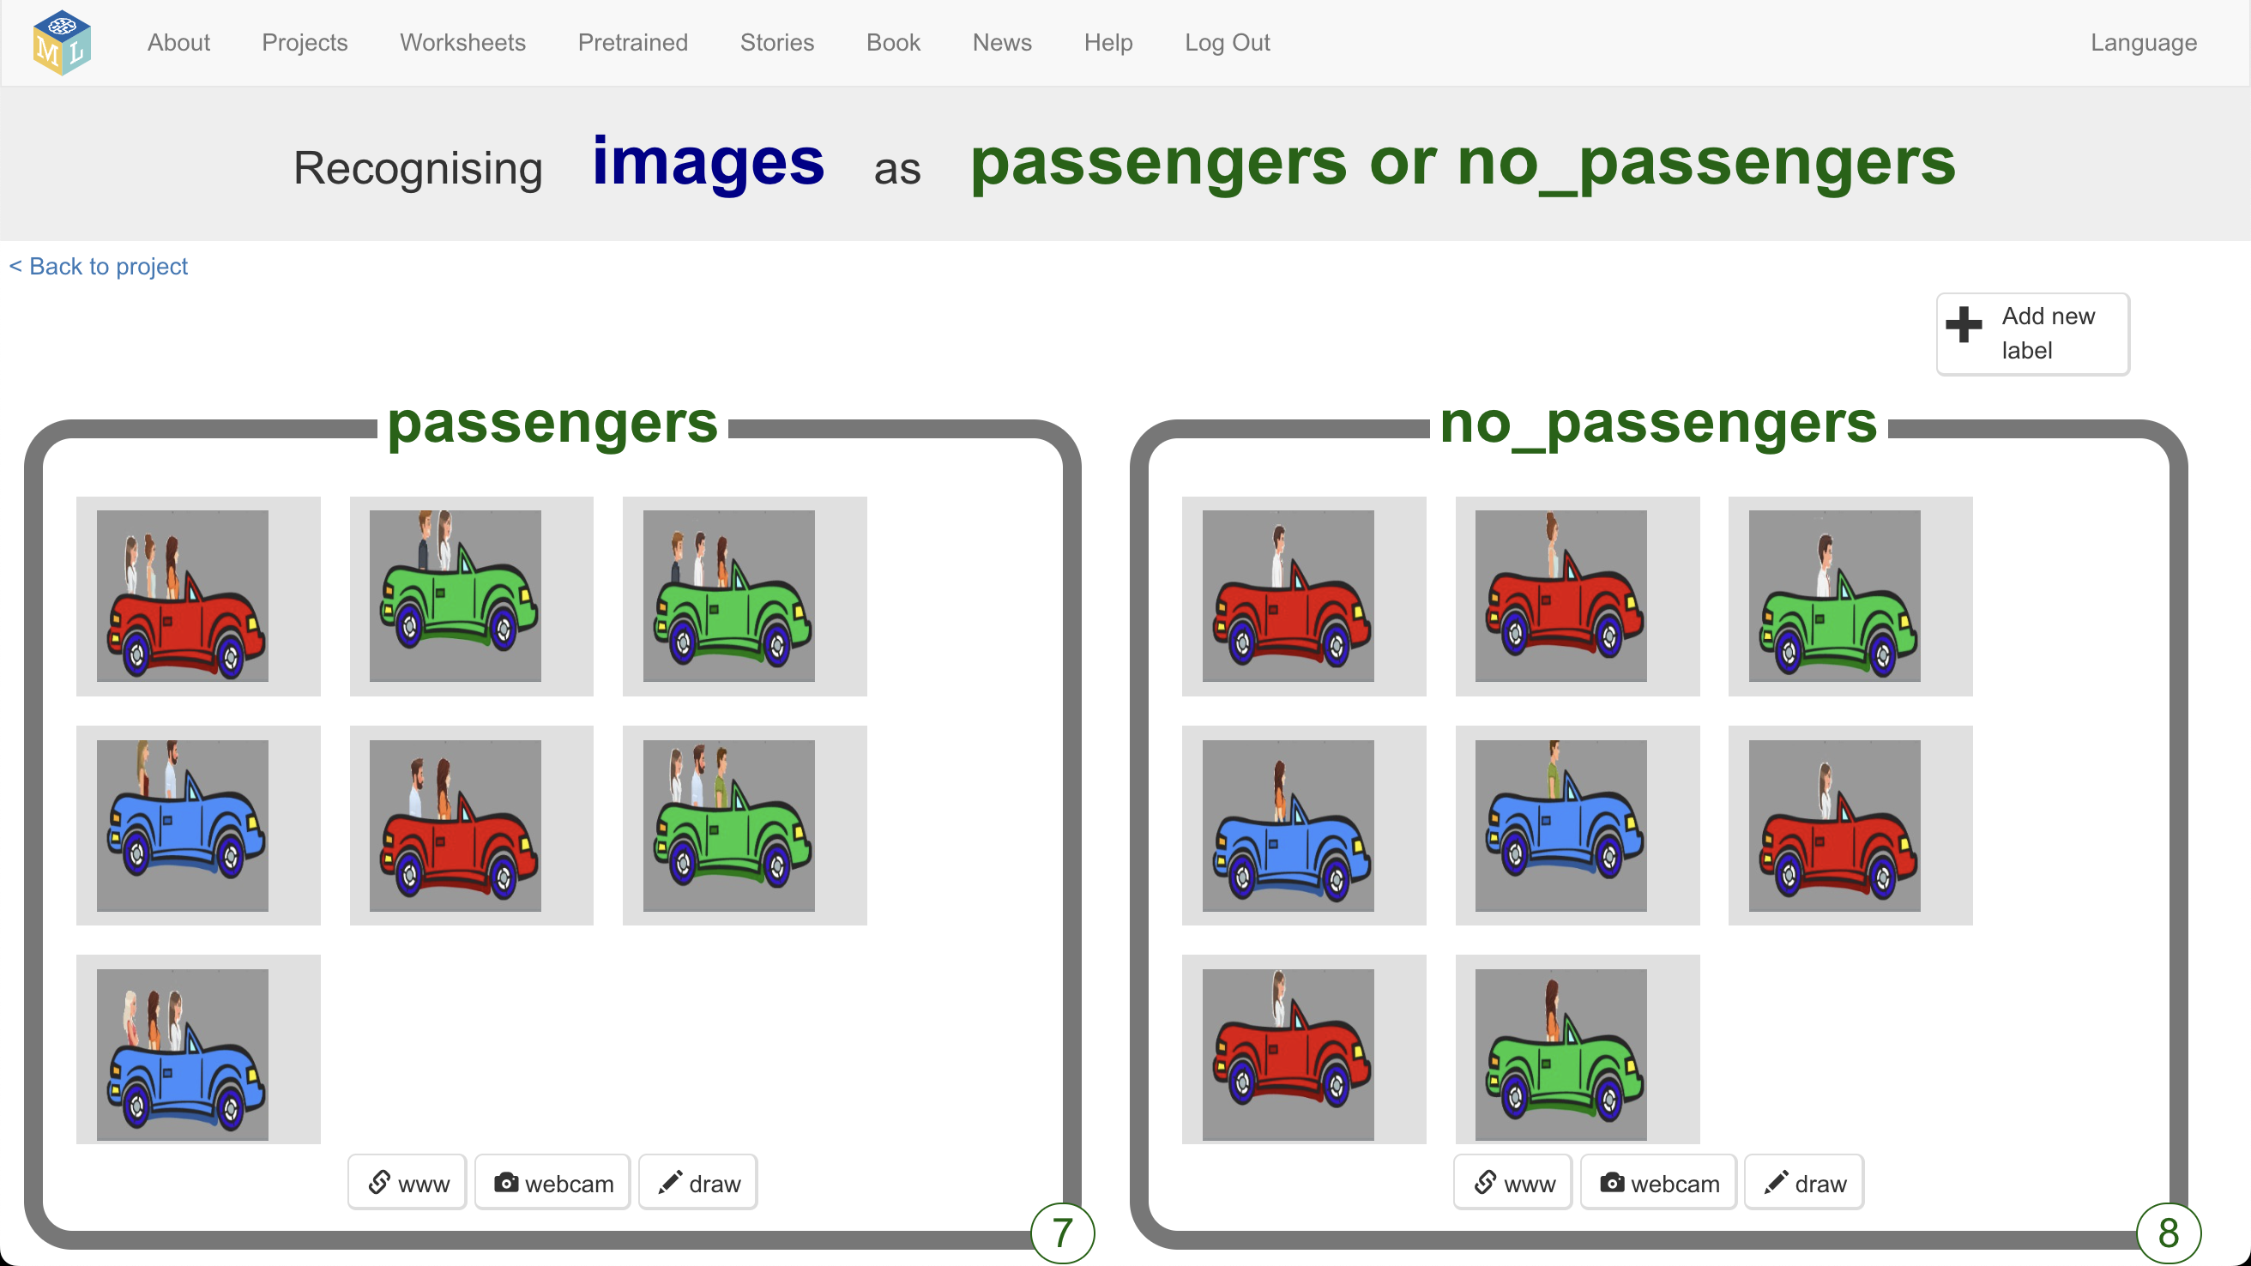
26. If you accidentally clicked the wrong button for any of the images, you can remove it by clicking on the red cross  
    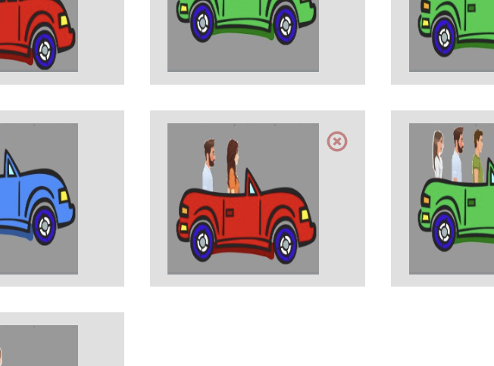
27. Once you have at least **five** example pictures in **both** training buckets, it is time to give your model a try.
28. Click on the “**< Back to project**” link
29. Click on the “**Make**” button.
30. Click on the “**Scratch 3**” button
31. Click on the “**straight into Scratch**” button  
    *This will open another, different, Scratch window.   
    Having two Scratch windows means you can use one for training, and one for testing.*
32. Click on the **Project templates** menu
33. Click on the “**Carpool Cheats (test)**” project

You will update it to get the traffic camera to use your machine learning model.

1. Click on the **Stage** and find the **prepare training labels** code  
   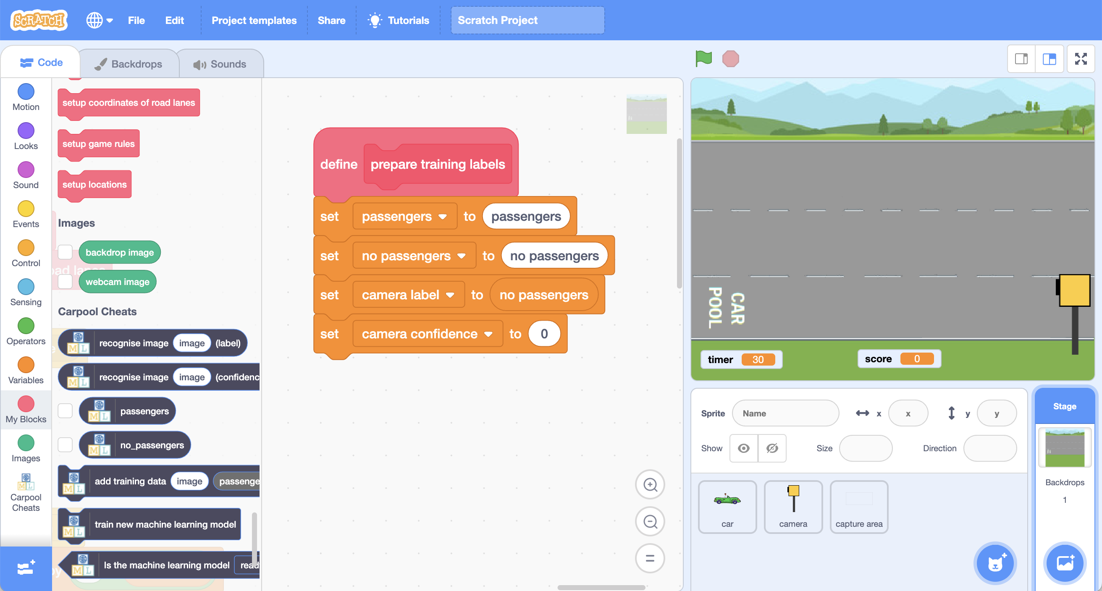
2. **Add** blocks from your machine learning project to this code  
   *You need to make it look like this:*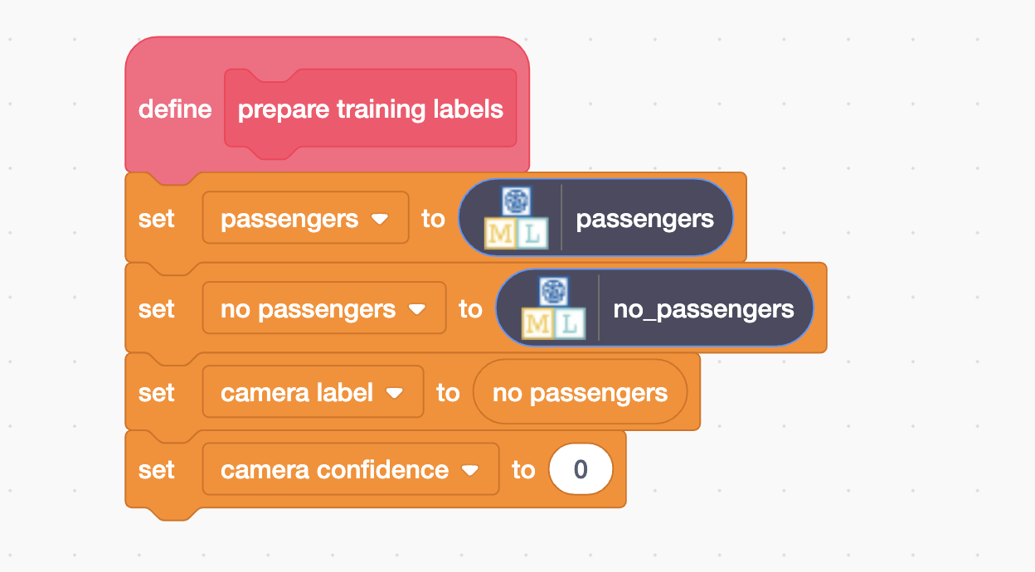
3. Find the “**when Green flag clicked**” code (still on the Stage)  
   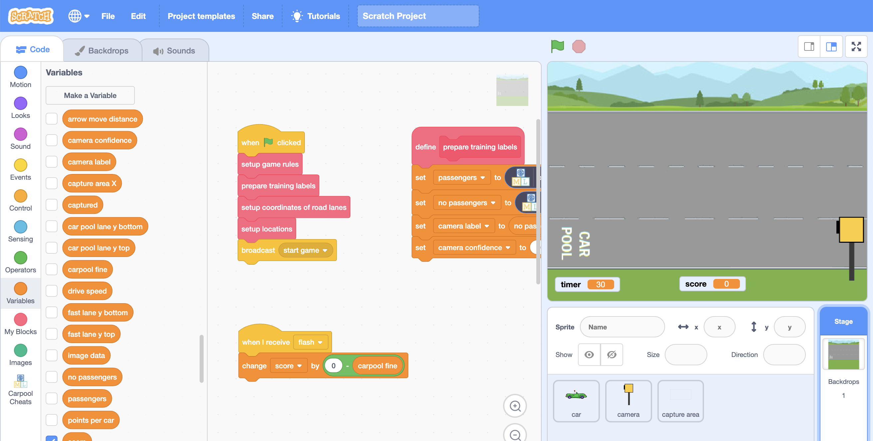
4. **Add** a block from your machine learning project to this code  
   *You need to make it look like this:  
   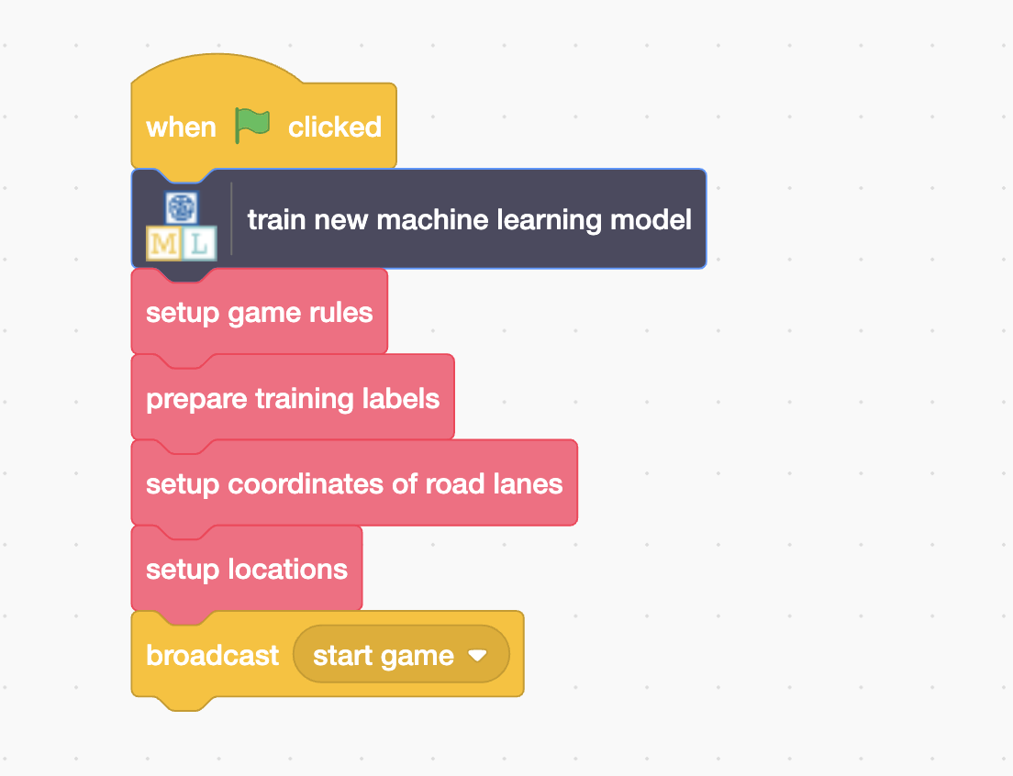*
5. Click on the **capture area** sprite and find the “**check car**” code  
   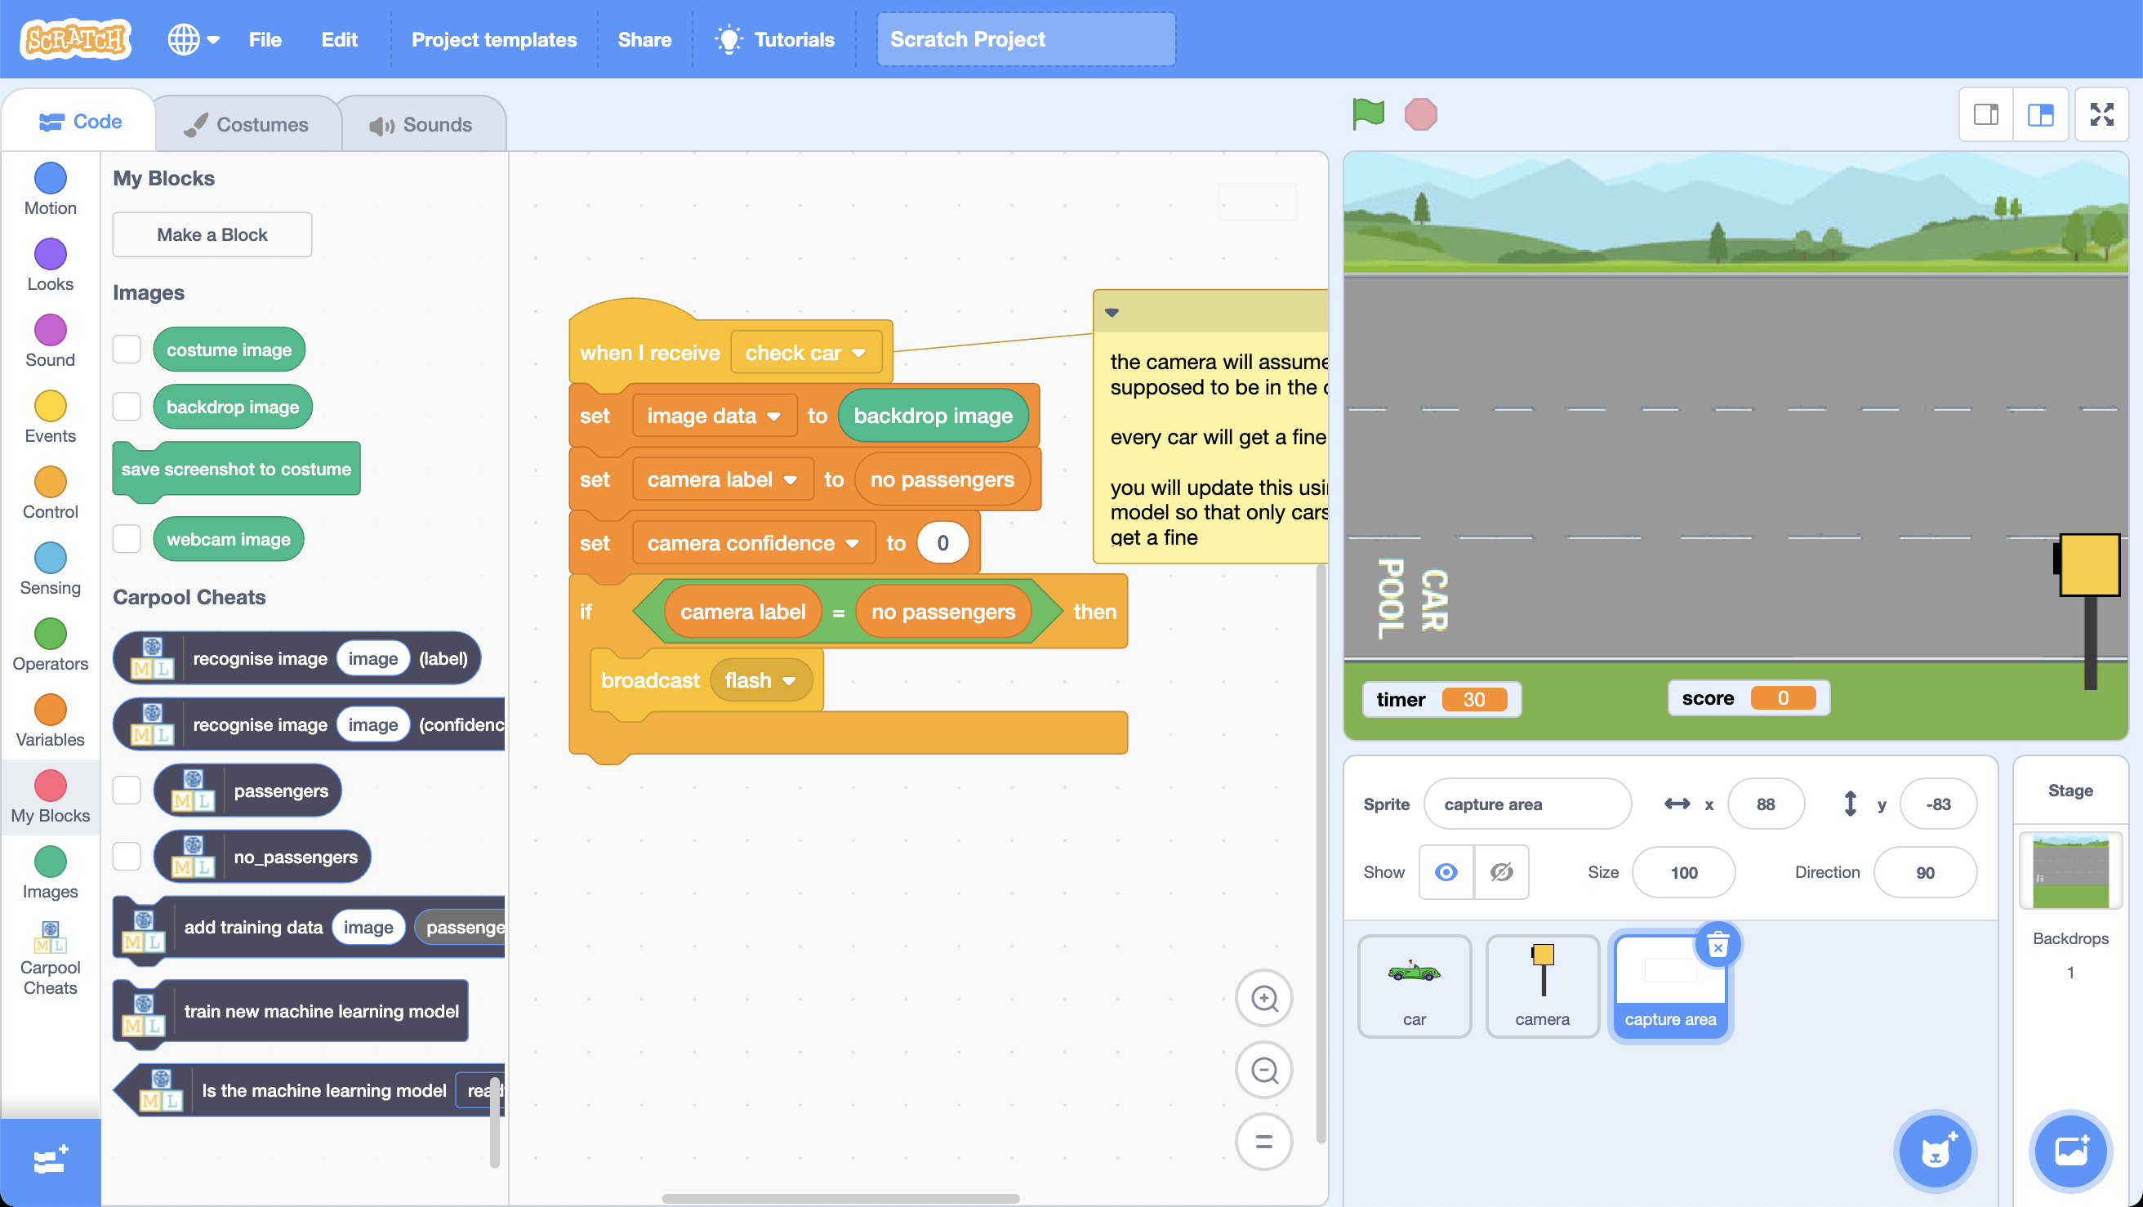
6. **Add** blocks from your machine learning project to this code  
   *You need to make it look like this: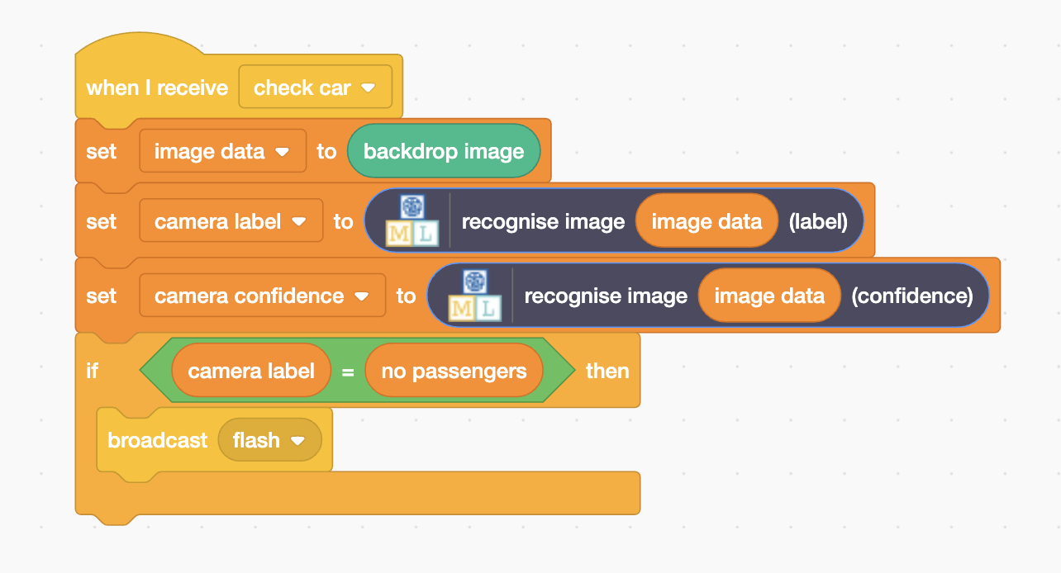 Move or delete the comment if it’s in your way while you update the code.*
7. Click on the **full-screen** button
8. Click on the **Green flag***It’s time to test!  
   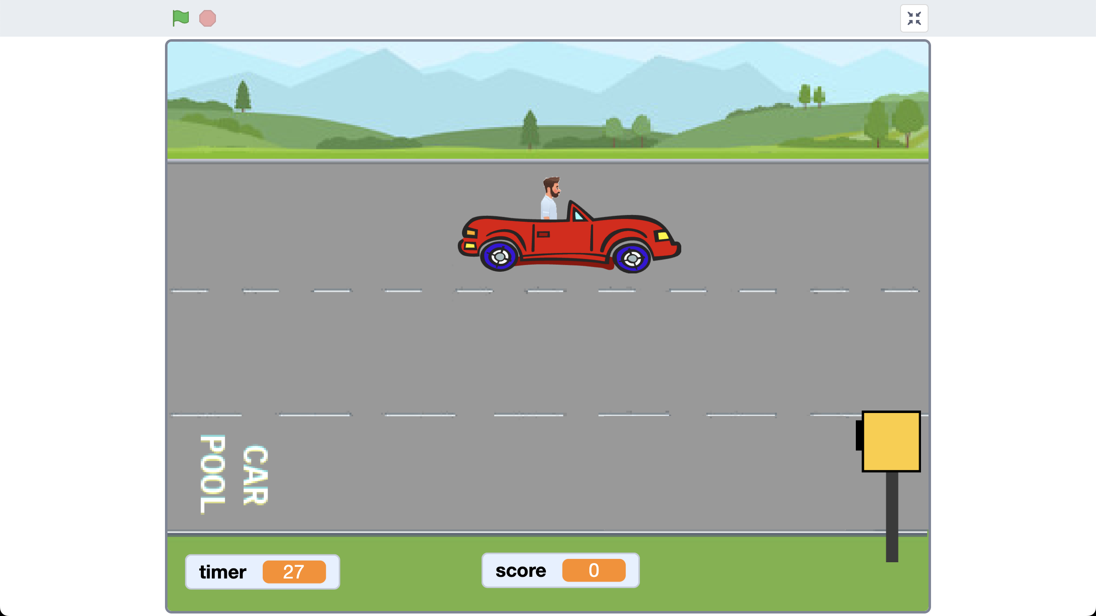*  
   *Play the game as you did before.   
     
   This time, your machine learning model should mean that the traffic camera only fines cars without passengers!*
9. If you want to see what your machine learning model is doing, tick the “camera label” and “camera confidence” variables  
   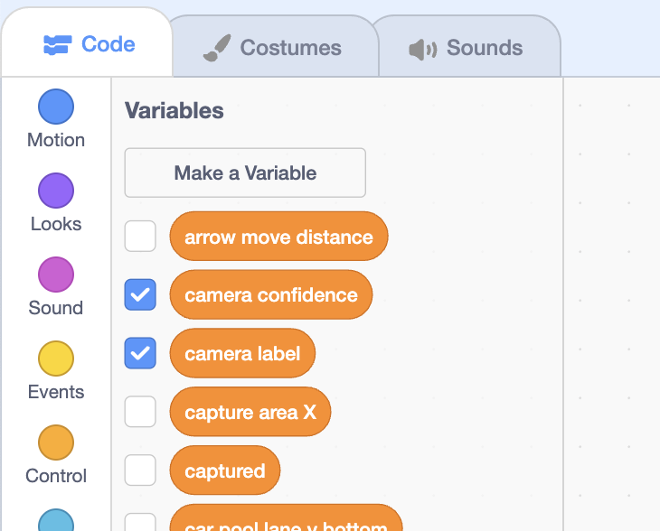  
     
   *This will display the results from your machine learning model when a car goes past the traffic camera*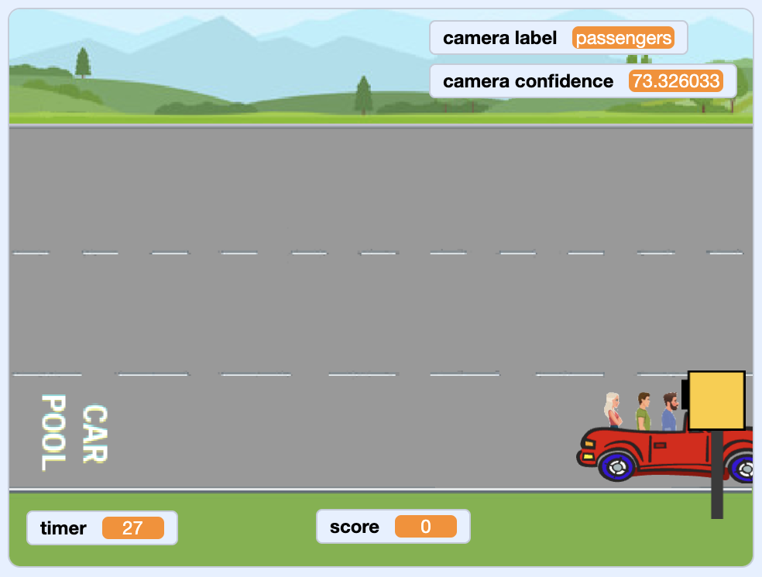
10. If your machine learning model makes too many mistakes, more training examples may improve it   
    *Go back to the Scratch window with the “****Carpool Cheats (train)****” project and collect another ten examples of pictures of cars.  
    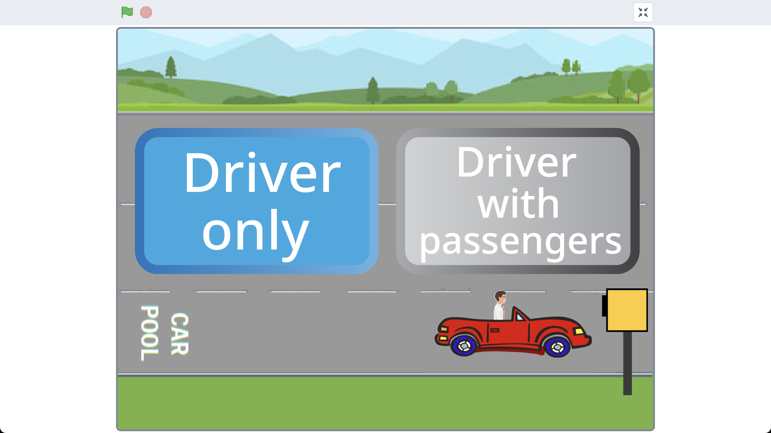*

**What have you done?**

You’ve trained a computer to recognise a picture of a car as having passengers or no passengers. Instead of trying to write rules to be able to do this, you did it by collecting examples. These examples were being used to train a machine learning “model”.

The computer will learn from patterns in the examples you’ve given it. These were used by the traffic camera to recognise new pictures.

**Ideas and Extensions**

Now that you’ve finished, why not give one of these ideas a try?

Or come up with one of your own?

**Write a reply**

Instead of just changing the way they look, make your character reply, based on what it recognises in the message!

**Try a different character**

Instead of a person’s face, why not try something different, like an animal?

For example, you could make a dog that wags their tail if you say something kind to it!

**Use the confidence score**

The other new Scratch block from your project gives the score for how sure your machine learning model is that it has recognised the message. How can you use this for messages that aren’t compliments or insults?

**Real world sentiment analysis**

Can you think of examples where it’s useful to be able to train a computer to recognise the emotion in writing?